MATLAB SIMULATION OF SUPERHETERODYNE RECEIVER FOR AM COMMUNICATION SYSTEM WITH FREQUENCY MIXING AND FILTERING
Objectives
i) To model and simulate the operation of a superheterodyne receiver for an AM communication system using MATLAB by implementing frequency mixing and intermediate frequency (IF) signal generation.
ii) To recover the original message signal through intermediate frequency filtering and envelope detection, and analyze the waveforms of the message, carrier, AM, IF, and recovered signals.
PROGRAM (MATLAB CODE)
clc;
clear;
close all;
% Parameters
fs = 100000;
t = 0:1/fs:0.02;
fm = 500; % Message frequency
fc = 10000; % Carrier frequency
fLO = 14550; % Local Oscillator (IF = 4550 Hz)
% Message Signal
m = cos(2*pi*fm*t);
% Carrier Signal
c = cos(2*pi*fc*t);
% AM Signal
am = (1 + m).*cos(2*pi*fc*t);
% Local Oscillator
LO = cos(2*pi*fLO*t);
% Frequency Mixing
mixed = am .* LO;
% IF Filter
[b,a] = butter(4,5000/(fs/2));
IF = filter(b,a,mixed);
% Envelope Detection
env = abs(hilbert(IF));
% Display
figure;
subplot(4,1,1)
plot(t,m)
title('Message Signal')
grid on
figure;
subplot(5,1,2)
plot(t,c)
title('Carrier Signal')
grid on
subplot(5,1,3)
plot(t,am)
title('AM Signal')
grid on
subplot(5,1,4)
plot(t,IF)
title('Intermediate Frequency (IF) Signal') grid on
subplot(5,1,5)
plot(t,env)
title('Recovered Signal')
grid on

OUTPUT:
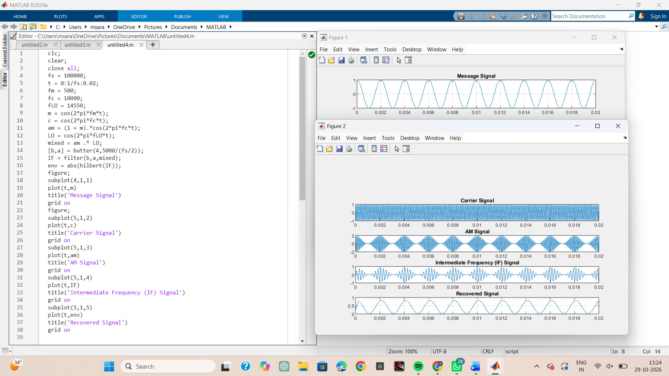
Result
The superheterodyne receiver was successfully simulated in MATLAB, and the message signal, carrier signal, AM signal, Intermediate Frequency (IF) signal, and recovered signal were obtained through frequency mixing and filtering.

